**Project: World Life Expectancy**

**Cleaning the data:**

**Query 1:**

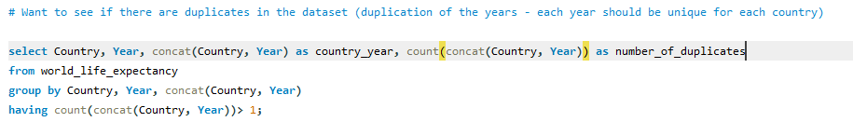

**Output:**

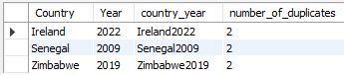

**Query 2:**

Now we need to delete these duplicates, so we will use the window function to select these columns again then delete them.

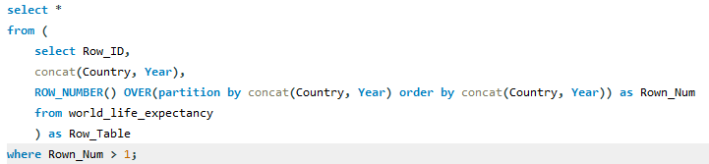

**Output:**

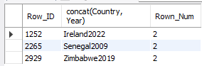

**Query 3:**

To delete the duplicates

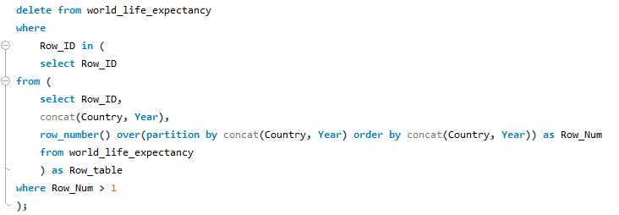

**Output:**

Deletion of the columns

**Query 4:**

We need to delete the blanks in the status column



**Output:**

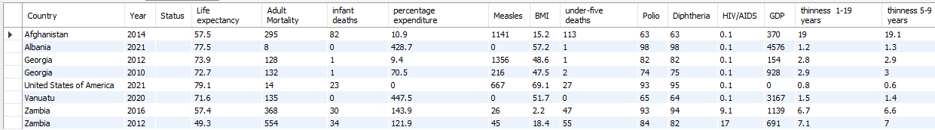

**Query 5:**

Query that shows the possible status listed in the status column:

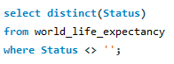

**Output:**

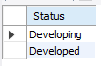

**Query 6:**

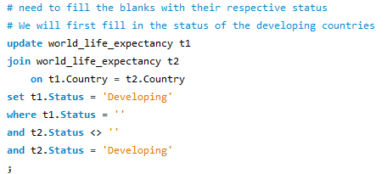

**Query 7:**

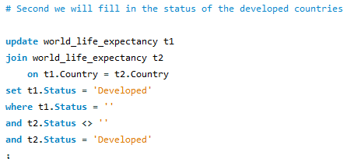

**Query 8:**

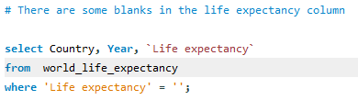

**Query 9:**

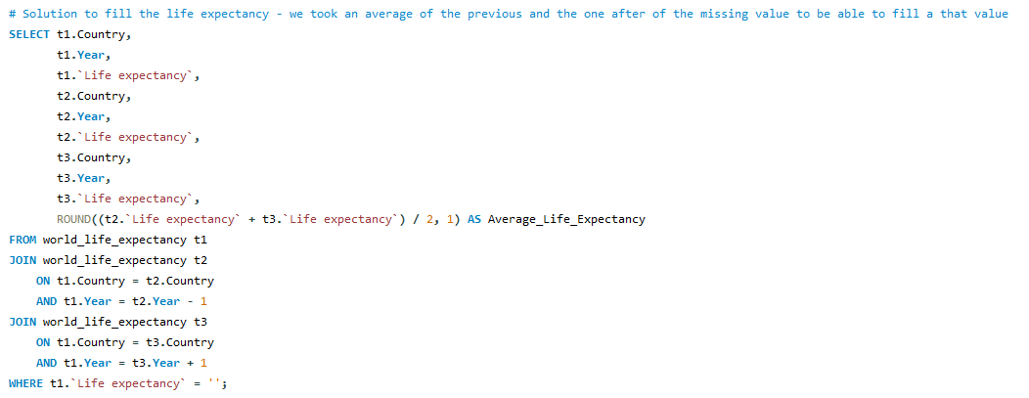

**Query 10:**

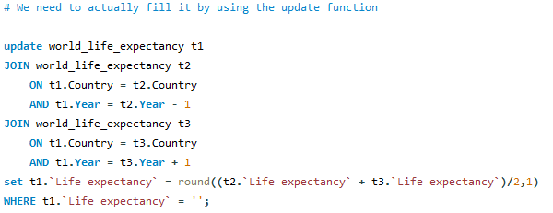

**Query 11:**

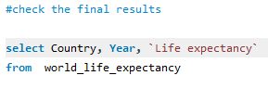

**Output:**

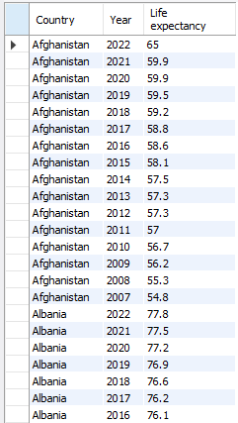

As you can see there are no missing values in the life expectancy column, we filled them all.

**World Life Expectancy EDA**

**Query 1:**

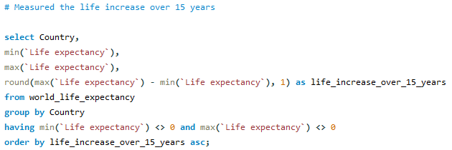

**Output:**

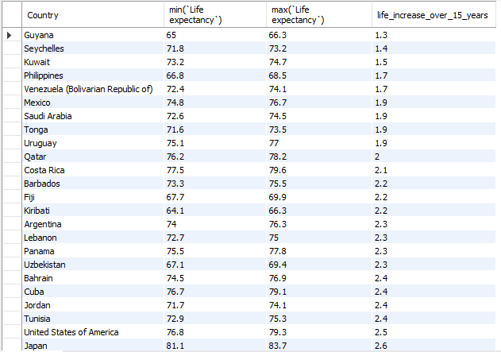

**Query 2:**

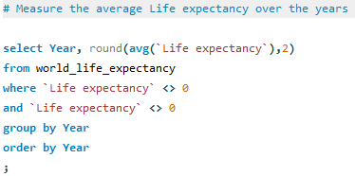

**Output:**

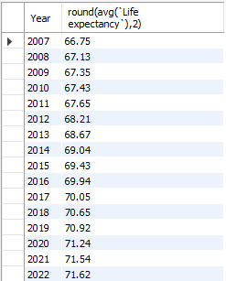

**Query 3:**

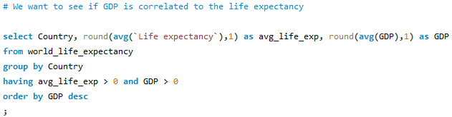

**Output:**

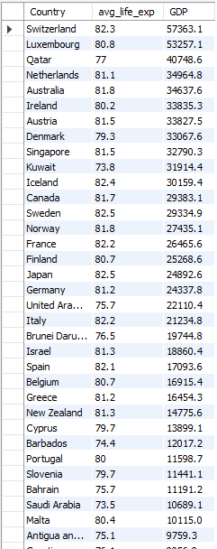(…)

**Query 4:**

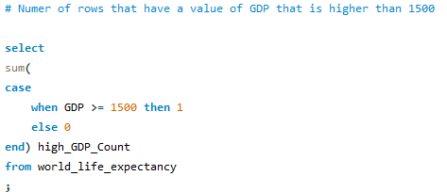

**Output:**



**Query 5:**

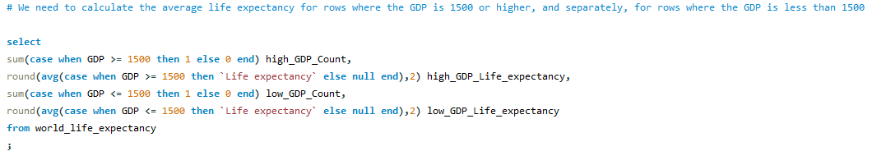

**Output:**



**Query 6:**

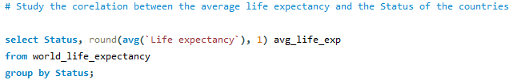

**Output:**



**Query 7:**

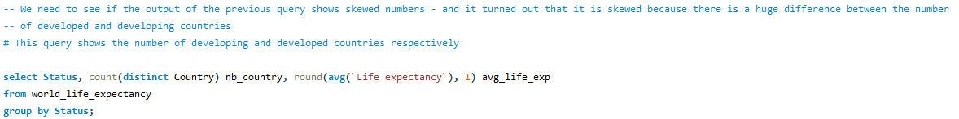

**Output:**



**Query 8:**

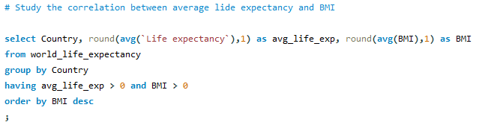

**Output:**

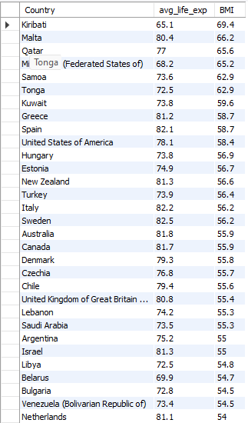

**Query 9:**

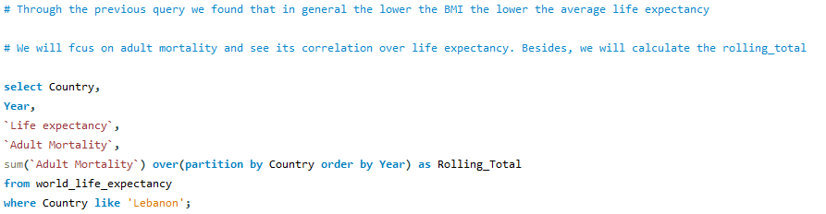

**Output:**

